# AVANISH RAJ SRIVASTAVA BT22CSH031 ASSIGNMENT 5

**1)**

#include <iostream> #include <vector>

using namespace std;

void heapify(vector<int>& arr, int n, int i) { int smallest = i;

int left = 2 * i + 1; int right = 2 * i + 2;

if (left < n && arr[left] < arr[smallest]) smallest = left;

if (right < n && arr[right] < arr[smallest]) smallest = right;

if (smallest != i) { swap(arr[i], arr[smallest]); heapify(arr, n, smallest);

}

}

void buildHeap(vector<int>& arr) { int n = arr.size();

for (int i = n / 2 - 1; i >= 0; i--) { heapify(arr, n, i);

}

}

void insert(vector<int>& arr, int value) { arr.push_back(value);

int index = arr.size() - 1;

while (index > 0 && arr[index] < arr[(index - 1) / 2]) { swap(arr[index], arr[(index - 1) / 2]);

index = (index - 1) / 2;

}

}

int main() {

vector<int> arr = {1, 5, 6, 8, 9, 7, 3};

buildHeap(arr);

cout << "Min Heap: "; for (int num : arr) {

cout << num << " ";

}

cout << endl;

int newValue = 4; insert(arr, newValue);

cout << "Min Heap after inserting " << newValue << ": "; for (int num : arr) {

cout << num << " ";

}

cout << endl;

return 0;

}

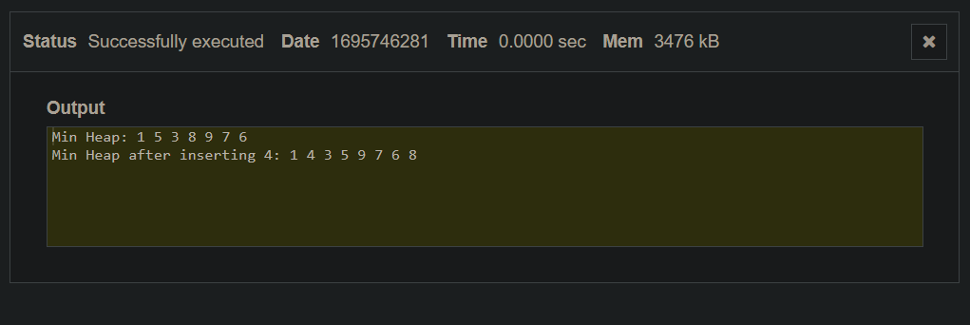

# 2)

#include <iostream> #include <vector>

using namespace std;

void heapify(vector<int>& arr, int n, int i, bool isMinLevel) { int largest = i;

int left = 2 * i + 1;

int right = 2 * i + 2;

if (isMinLevel) {

if (left < n && arr[left] < arr[largest]) largest = left;

if (right < n && arr[right] < arr[largest]) largest = right;

} else {

if (left < n && arr[left] > arr[largest]) largest = left;

if (right < n && arr[right] > arr[largest]) largest = right;

}

if (largest != i) { swap(arr[i], arr[largest]);

heapify(arr, n, largest, !isMinLevel);

}

}

int deleteMax(vector<int>& arr) { if (arr.empty()) {

cerr << "Heap is empty!" << endl;

return -1; // Return a sentinel value to indicate an empty heap.

}

int maxElement = arr[0];

int lastIndex = arr.size() - 1;

swap(arr[0], arr[lastIndex]);

arr.pop_back();

bool isMinLevel = true; // Root is at the min-level heapify(arr, arr.size(), 0, isMinLevel);

return maxElement;

}

int main() {

vector<int> minMaxHeap = {9, 8, 6, 7, 5, 1, 3};

cout << "Max Element Deleted: " << deleteMax(minMaxHeap) << endl; cout << "Remaining Min-Max Heap: ";

for (int num : minMaxHeap) { cout << num << " ";

}

cout << endl;

return 0;

}

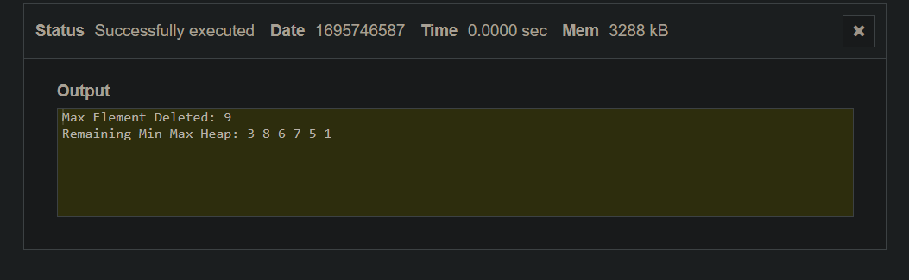

# 3)

#include <iostream> #include <vector>

using namespace std;

void heapify(vector<int>& arr, int n, int i) { int largest = i;

int left = 2 * i + 1; int right = 2 * i + 2;

if (left < n && arr[left] > arr[largest]) largest = left;

if (right < n && arr[right] > arr[largest]) largest = right;

if (largest != i) { swap(arr[i], arr[largest]); heapify(arr, n, largest);

}

}

void buildMaxHeap(vector<int>& arr) { int n = arr.size();

for (int i = n / 2 - 1; i >= 0; i--) { heapify(arr, n, i);

}

}

void heapSort(vector<int>& arr) { int n = arr.size();

buildMaxHeap(arr);

for (int i = n - 1; i > 0; i--) {

swap(arr[0], arr[i]);

heapify(arr, i, 0);

}

}

int main() {

vector<int> arr = {12, 11, 13, 5, 6, 7};

cout << "Original Array: "; for (int num : arr) {

cout << num << " ";

}

cout << endl; heapSort(arr);

cout << "Sorted Array: "; for (int num : arr) {

cout << num << " ";

}

cout << endl;

return 0;

}

